Contents

1. Introduction 4

Growth Industry: Definition, Driving Factors, and Characteristics 4

Growth of products industry 4

What is spurring product industry 4

Different product categories 5

Project business vs Product business 5

What is Product management 6

What Is a Growth Industry? 7

Understanding Growth Industries 7

Characteristics of Growth Industries 8

Growth Industries and CAGR 9

What is a unicorn? 9

What triggered the unicorn rush during 2021? 9

Unicorns Of India 10

Investors in Unicorns 11

Unicorn Sector Snaps 11

What is a product category? 12

Product category definition 12

Why is it important to create product categories? 12

What are some examples of product categories? 13

Product category by PPT 13

Differences Between Project- and Product-Oriented Management 13

2. Overview of Product Management 14

Evolution of product companies 14

Product-Market fit concept 15

Why products fail? 16

What do best product teams do? 17

Tackle risks early 17

Product management and rest of the company 18

Product Lifecycle 19

Technology adoption lifecycle (Crossing the Chasm) 19

Journey of some product companies – Netflix, Google, Microsoft (Internet) 20

Multi-faceted role of a Product manager (Inspired, Product leadership) 21

3. Core concepts 22

Principles of product management 22

Aspects of a product – a holistic definition 23

Product-Market fit (LPP) 23

Problem space vs Solution space 24

User vs buyer 25

Continuous discovery and delivery 25

Product eco-system 26

Critical success factors 26

4. Product process 27

Overview of the process (Inspired + Lean Startup) 27

Build-Measure-Learn cycle 28

Identify opportunity 29

Identifying underserved customer needs (LPP) 29

Sources of innovation (Peter Drucker) 30

Hack days (Inspired) 30

Ideation techniques (Cooper & Edgett) 31

Assess the opportunity (Inspired – Product discovery) 31

Define value proposition 32

Assess the value of the product 32

Risks assessment – Value risk, Usability risk, Technical feasibility risk & Business viability risk 33

Create business plan – Start-up canvas 34

Story map 35

Capturing features using Story Map 35

Release planning using Story Map 36

Prioritizing features using Kano model 37

Story map: Job portal 38

Story map: Hotel booking software 38

Story map: Email system 39

Create Minimum Viable Product (MVP) (LPP) 39

What is MVP? 40

MVP types 40

When to use which MVP 41

Build-Measure-Learn (Lean Start-up) 42

Build – Turn ideas into product 42

Measure – See how customers respond 43

Learn – Pivot or persevere 43

Profile: Kate Arnold of Netflix (Inspired) 44

Question paper Mid term solution 45

1 Ans: 45

2 Ans: 46

3 Ans: 47

# Introduction

## Growth Industry: Definition, Driving Factors, and Characteristics

## Growth of products industry

The product industry has experienced significant growth over the years, driven by advancements in technology, changes in consumer behavior, and globalization. Here are some key factors that have contributed to the growth of the products industry:

1. Technology Advancements: Technology has revolutionized the way products are designed, developed, and marketed. The widespread availability of the internet and mobile devices has enabled companies to reach global audiences and engage with customers in new and innovative ways.
2. Changing Consumer Behavior: Consumers today are more informed, connected, and demanding than ever before. They expect products to be tailored to their individual needs and preferences, and they are willing to pay a premium for products that offer a superior user experience.
3. Globalization: The rise of globalization has created new opportunities for companies to expand their reach and tap into new markets. This has led to increased competition and a greater focus on product innovation and differentiation.
4. E-commerce: The growth of e-commerce has made it easier for companies to sell products directly to consumers, bypassing traditional retail channels. This has enabled smaller companies to compete with larger ones and has led to a greater emphasis on product quality and value.
5. Social Media: Social media has become a powerful marketing tool for product companies, allowing them to engage with customers, build brand awareness, and gather feedback in real-time.

Overall, the products industry is poised for continued growth as companies continue to innovate and meet the changing needs and preferences of consumers around the world. However, with this growth comes the challenge of staying competitive and relevant in a rapidly evolving marketplace. Companies must be agile, adaptable, and customer-focused in order to succeed in the products industry

## What is spurring product industry

The product industry is being spurred by a variety of factors, including:

1. Technology Advancements: Advances in technology, including artificial intelligence, the internet of things (IoT), and automation, are driving innovation and creating new product opportunities across a range of industries.
2. Changing Consumer Behaviors: Consumers are demanding products that are tailored to their individual needs and preferences, and they are increasingly willing to pay a premium for products that offer a superior user experience.
3. Globalization: The rise of globalization has created new opportunities for companies to expand their reach and tap into new markets, spurring innovation and competition.
4. E-commerce: The growth of e-commerce has made it easier for companies to sell products directly to consumers, bypassing traditional retail channels and creating new distribution channels.
5. Social Media: Social media has become a powerful marketing tool for product companies, allowing them to engage with customers, build brand awareness, and gather feedback in real-time.

Overall, the product industry is being spurred by a combination of technological advancements, changing consumer behaviors, globalization, and the rise of new distribution channels. Companies that are able to innovate and adapt to these changes are well-positioned for growth and success in the years ahead

## Different product categories

There are a variety of ways to categorize products, but here are some common categories:

1. Consumer Goods: These are products that are purchased by individuals for personal use or consumption, such as clothing, food, and household items.
2. Industrial Goods: These are products that are used in the production of other goods or in the provision of services, such as machinery, raw materials, and construction equipment.
3. Digital Products: These are products that are delivered digitally, such as software, music, and ebooks.
4. Services: These are intangible products that are provided to customers, such as banking, healthcare, and consulting services.
5. Luxury Products: These are products that are priced higher than similar products due to their high quality, exclusivity, or brand image, such as high-end fashion, jewelry, and automobiles.
6. Convenience Products: These are products that are purchased frequently and with little effort, such as fast food, snack foods, and toiletries.
7. Specialty Products: These are products that are unique or difficult to find, and are often targeted at niche markets, such as artisanal foods, specialty clothing, and collector's items.

Overall, product categories are important for companies to consider when developing their marketing strategies, as different categories require different approaches to pricing, distribution, and promotion

## Project business vs Product business

Project business and product business are two different types of business models.

A **project business** is a type of business that provides customized solutions for specific client needs. Project businesses often involve short-term engagements, where a team is assembled to deliver a unique solution for a client. Examples of project businesses include architecture firms, engineering firms, and consulting firms.

A **product business**, on the other hand, is a type of business that creates and sells products to a wide range of customers. Product businesses focus on developing and marketing products that are standardized and can be mass-produced. Examples of product businesses include consumer goods companies, technology companies, and pharmaceutical companies.

There are several key differences between project business and product business models. One major difference is that project businesses rely on customization and innovation to deliver unique solutions to clients, while product businesses rely on efficiency and scalability to deliver standardized products to a wide customer base. Additionally, project businesses often have a more variable revenue stream, as revenue is tied to the completion of specific projects, while product businesses can have more stable revenue streams due to ongoing sales of standardized products.

Ultimately, the choice between a project business and a product business model will depend on the specific industry, market, and business goals of a company. Both models have their advantages and disadvantages, and companies may choose to pursue one model over the other based on their unique circumstances

## What is Product management

Product management is a strategic business function that involves identifying, developing, and launching products or services that meet the needs of a target market. Product managers are responsible for overseeing the entire lifecycle of a product, from ideation and development to launch and ongoing support.

Some key responsibilities of a product manager include:

1. Market research: Conducting research to identify customer needs and market trends, and using this information to develop new product ideas.
2. Product strategy: Developing a product strategy that aligns with the overall goals and objectives of the company, and prioritizing product features and functionality based on customer needs and market trends.
3. Product development: Overseeing the development of the product, including defining product requirements, working with engineering and design teams, and ensuring that the product meets customer needs and company goals.
4. Launch and go-to-market: Developing a go-to-market strategy that includes pricing, promotion, and distribution, and ensuring that the product is successfully launched to the target market.
5. Ongoing product management: Monitoring the performance of the product, gathering customer feedback, and making changes and updates to the product based on customer needs and market trends.

Overall, product management is a critical function within a company that requires a combination of strategic thinking, technical knowledge, and customer insight. Successful product managers are able to balance these different factors to develop and launch products that meet the needs of their target market and drive business growth

## What Is a Growth Industry?

A growth industry is a sector of the economy that is experiencing rapid expansion and increasing demand. Growth industries are characterized by high levels of investment, innovation, and job creation. They often emerge from new technologies or changing consumer behaviors, and they offer significant growth potential for companies and investors.

Some examples of growth industries in recent years include:

1. Technology: The technology industry, including software, hardware, and telecommunications, has experienced rapid growth in recent years, driven by advancements in mobile devices, cloud computing, and artificial intelligence.
2. Healthcare: The healthcare industry, including biotechnology, pharmaceuticals, and medical devices, has also experienced strong growth due to an aging population, increasing demand for healthcare services, and advancements in medical technology.
3. Renewable Energy: The renewable energy industry, including solar, wind, and hydropower, has experienced significant growth in recent years due to concerns about climate change and the push for cleaner, more sustainable energy sources.
4. E-commerce: The e-commerce industry, including online retailers and marketplaces, has seen explosive growth in recent years, driven by changing consumer behavior and the increasing popularity of online shopping.

Overall, growth industries offer significant opportunities for companies and investors, but they also come with risks and challenges. Companies must be able to innovate and adapt quickly to stay competitive in a rapidly evolving marketplace, and investors must be prepared to navigate the ups and downs of a dynamic industry.

## Understanding Growth Industries

A growth industry is an industry that is expanding rapidly and is expected to continue to do so in the future. These industries typically have high growth rates, significant market demand, and strong profit potential.

Some examples of growth industries include:

1. Technology: The technology industry is one of the fastest-growing industries globally, driven by ongoing innovation and increasing demand for digital products and services.
2. Healthcare: The healthcare industry is experiencing rapid growth due to an aging population and increased demand for healthcare services and products.
3. Renewable Energy: The renewable energy industry is growing rapidly as the world shifts towards cleaner sources of energy.
4. E-commerce: The e-commerce industry has experienced explosive growth in recent years, as more consumers shift towards online shopping.
5. Cybersecurity: The cybersecurity industry is growing rapidly due to increasing concerns around cyber threats and data security.

Growth industries typically offer significant opportunities for companies to expand their operations and generate higher profits. However, they also present significant challenges, such as intense competition and the need to stay ahead of rapidly evolving market trends and technologies.

To succeed in a growth industry, companies need to stay agile, innovative, and customer-focused. They must be willing to invest in research and development, cultivate a strong brand and reputation, and adapt quickly to changes in the market. Additionally, companies in growth industries must be prepared to navigate regulatory and legal challenges, manage risks, and make strategic investments to fuel their growth.

## Characteristics of Growth Industries

Growth industries typically exhibit several key characteristics that distinguish them from other industries. Here are some of the common characteristics of growth industries:

1. High Growth Rates: Growth industries typically experience high rates of growth in terms of sales, profits, and employment. These industries are often driven by innovation and new technologies that create new opportunities and disrupt existing markets.
2. Increasing Market Demand: Growth industries are characterized by increasing market demand for products or services. This demand is often driven by changing consumer preferences or behaviors, shifts in demographics, or regulatory changes.
3. Strong Profit Potential: Growth industries offer significant profit potential for companies that are able to capture market share and establish a strong competitive position. Companies that are able to innovate, develop new products and services, and achieve economies of scale can generate substantial profits in growth industries.
4. Technological Advancements: Growth industries are often characterized by rapid technological advancements, which create new opportunities for innovation and disruption. Companies that are able to stay ahead of these technological trends can gain a significant competitive advantage.
5. Emerging Markets: Growth industries often emerge in new or emerging markets, which offer significant growth opportunities for companies that are able to establish a strong presence. These emerging markets may be in developing countries, new geographic regions, or new industry segments.
6. Intense Competition: Growth industries are often characterized by intense competition, as companies vie for market share and seek to establish a dominant position in the market. This competition can drive innovation and product development, but it can also create significant challenges for companies that are not able to keep pace with their competitors.

Overall, growth industries offer significant opportunities for companies that are able to capitalize on emerging trends, stay ahead of technological advancements, and establish a strong competitive position. However, they also present significant challenges, including intense competition and the need to stay agile and innovative in a rapidly changing market

## Growth Industries and CAGR

Compound Annual Growth Rate (CAGR) is a widely used metric for measuring the growth of a business or industry over a period of time. It is calculated as the average annual growth rate of an investment over a specified period of time.

Growth industries often exhibit high CAGRs, as they are characterized by rapid growth in sales, profits, and employment. CAGR can be used to measure the growth of an industry or a company within that industry over a period of time, and can be used to forecast future growth rates as well.

For example, if an industry experiences a 20% growth rate over a period of five years, the CAGR for that industry would be approximately 3.7% (calculated as (1+0.20)^(1/5)-1). This means that the industry grew at an average annual rate of 3.7% over the five-year period.

CAGR is often used to compare the growth rates of different industries or companies, and to evaluate investment opportunities in those industries. It is also used by companies to set growth targets and to measure their performance against those targets.

Overall, CAGR is a useful metric for measuring the growth of an industry or company over time, and can provide valuable insights into the potential for future growth in a particular industry. In growth industries, high CAGRs are often an indication of strong market demand and a favorable business environment, which can attract investors and fuel further growth

## What is a unicorn?

In the business world, a unicorn is a term used to describe a privately held startup company with a valuation of over $1 billion. The term was first coined by venture capitalist Aileen Lee in 2013, in an article for TechCrunch.

Unicorns are rare and highly valued, and the term is often used to refer to the most successful and promising startups. Some well-known examples of unicorns include companies like Uber, Airbnb, and SpaceX.

The term "unicorn" is often used to highlight the rapid growth and potential of these startups, which are often in the technology industry. However, some critics argue that the term is overused and can create unrealistic expectations for startup founders and investors.

Overall, the term "unicorn" is used to describe a select group of highly successful and valuable startups that have the potential to disrupt entire industries and change the way we live and work.

Top of Form

## What triggered the unicorn rush during 2021?

The unicorn rush that occurred in 2021 was largely triggered by the COVID-19 pandemic and the shift towards remote work and online services.

As people around the world were forced to stay home and work remotely, there was a huge increase in demand for online services and digital products. This led to a surge in investment in startups that were offering innovative solutions to meet these new demands.

Additionally, the low interest rates and the availability of venture capital funding further fueled the unicorn rush in 2021. Many investors were looking for high-growth opportunities that could generate significant returns, and startups with promising business models and growth potential became highly sought after.

Another factor that contributed to the unicorn rush was the growing interest in technologies such as artificial intelligence, machine learning, and blockchain. Startups that were developing these technologies and applying them to different industries were able to attract significant investment and achieve unicorn status.

Overall, the unicorn rush of 2021 was driven by a combination of factors including the COVID-19 pandemic, the shift towards online services, low interest rates, and the availability of venture capital funding. Additionally, the increasing focus on emerging technologies and their potential to disrupt traditional industries also played a significant role.

## Unicorns Of India

India has emerged as a major player in the global startup ecosystem in recent years, with a growing number of unicorns that have achieved significant success and garnered substantial investments. Some of the notable unicorns of India include:

1. Flipkart - An e-commerce platform that was acquired by Walmart for $16 billion in 2018.
2. Paytm - A mobile payments and financial services company that has raised over $2 billion in funding.
3. Ola - A ride-hailing platform that has raised over $4 billion in funding and expanded to several international markets.
4. Byju's - An edtech platform that provides online learning and test preparation courses and has raised over $1 billion in funding.
5. Zomato - A food delivery and restaurant discovery platform that has raised over $2 billion in funding and expanded to several international markets.
6. Swiggy - Another food delivery platform that has raised over $1 billion in funding and expanded to several Indian cities.
7. Udaan - A B2B e-commerce platform that connects small and medium-sized businesses with suppliers and has raised over $1 billion in funding.
8. Policybazaar - An online insurance marketplace that has raised over $1 billion in funding.
9. PhonePe - A mobile payments and financial services company that has raised over $700 million in funding.
10. InMobi - A mobile advertising platform that has raised over $1 billion in funding and operates in several international markets.

These unicorns and many others in India have shown significant growth and have disrupted traditional industries, demonstrating the potential of the Indian startup ecosystem

## Investors in Unicorns

Unicorns, which are privately held startups that have reached a valuation of $1 billion or more, attract a variety of investors from different backgrounds. Some of the common types of investors in unicorns include:

1. Venture Capital Firms - Venture capital (VC) firms are a major source of funding for unicorns. These firms invest in early-stage startups with high growth potential and often take an active role in helping the startups grow and scale. Examples of VC firms that have invested in unicorns include Sequoia Capital, Andreessen Horowitz, and SoftBank Vision Fund.
2. Angel Investors - Angel investors are high net worth individuals who provide funding to startups in exchange for equity. They often invest in early-stage startups and can provide mentorship and guidance to the founders. Examples of angel investors who have invested in unicorns include Peter Thiel and Ashton Kutcher.
3. Corporations - Some corporations invest in unicorns as a way to gain exposure to new technologies and business models. For example, Google's parent company, Alphabet, has invested in several unicorns such as Uber and Airbnb.
4. Sovereign Wealth Funds - Sovereign wealth funds are investment funds owned by governments that invest in a variety of assets, including startups. Examples of sovereign wealth funds that have invested in unicorns include Abu Dhabi Investment Authority and Singapore's Temasek Holdings.
5. Family Offices - Family offices are private wealth management firms that manage the assets of wealthy families. They often invest in unicorns as a way to diversify their portfolios and generate high returns.

Overall, unicorns attract a diverse range of investors who are looking for high-growth opportunities and are willing to take on a higher level of risk in exchange for potentially high returns.

## Unicorn Sector Snaps

Healthcare

The HealthTech market in India is estimated reach $ 5 Bn by 2023, growing at a CAGR of 39% post the pandemic impact. Digital shift, use of better technology, and favourable government policies are facilitating the growth of the market.

Noida-based healthtech startup Innovaccer has become the first Indian unicorn in the healthcare sector currently valued at $ 1.3 Bn. Innovaccer analyses healthcare data to provide actionable insights to healthcare providers, hospitals, insurance companies and other organisations and businesses.

Earlier this year, Pharmeasy, an online pharmacy and diagnostics brand, became a unicorn, bagging a valuation close to $ 1.5 Bn. The online pharmacy is now planning to go public soon, eyeing a valuation of about $ 7 Bn through its IPO.

Tata 1mg, Cure.fit and Pristyn Care have joined the unicorn club bringing the total number of Healthcare unicorns to 5 with a total valuation of $ 12.79 Bn

The heathcare segment in India is soon to see added number of unicorns with the growth of health-tech startups such as Practo, HealthifyMe etc

## What is a product category?

### Product category definition

A product category is a grouping of products that share similar characteristics or are used for similar purposes. Product categories are used by businesses to organize their inventory and communicate to customers what their products are and what they do.

For example, a business that sells shoes may have different product categories such as running shoes, dress shoes, sandals, and boots. Each of these product categories would contain a range of different products that share similar characteristics such as style, materials, or intended use.

Product categories can be defined in a number of different ways depending on the business and the market they are operating in. Some businesses may use more general product categories such as "clothing" or "electronics," while others may use more specific categories such as "smartphones" or "fitness trackers."

Defining product categories is an important part of product management, as it helps businesses to better understand their market, organize their inventory, and communicate to customers what their products are and what they do. By defining product categories, businesses can also identify trends in the market and develop new products that meet the needs of customers.

.

## Why is it important to create product categories?

Creating product categories is important for several reasons:

1. Market positioning: Product categories help to position products within a market. By defining a product category, businesses can communicate what their product is, what it does, and how it compares to other products in the same category.
2. Targeting specific audiences: Product categories help businesses to target specific audiences. For example, if a business creates a product category for "luxury watches," they can target consumers who are interested in high-end, high-quality watches.
3. Organizing inventory: Product categories help to organize inventory and make it easier for customers to find what they are looking for. By grouping products into categories, businesses can help customers quickly and easily find products that meet their needs.
4. Identifying trends: Product categories can help businesses identify trends in the market. By analyzing sales data for specific product categories, businesses can identify which products are selling well and which ones are not. This can help businesses make informed decisions about which products to promote or discontinue.
5. Product development: Product categories can help businesses to identify opportunities for product development. By analyzing existing product categories and identifying gaps in the market, businesses can develop new products that meet the needs of customers.

Overall, creating product categories is an important part of product management. It helps businesses to better understand their market, target specific audiences, organize their inventory, identify trends, and develop new products.

## What are some examples of product categories?

Skincare brands are a great place to look to see different product categories. Skincare brands will have a category for each product type (cleanser, toner, moisturizer, etc.) but may also categorize by skin type (oily, dry, combination, etc.).

Clothing stores have categories for men, women, and children but then further break down those into subcategories, such as tops, outerwear, and bottoms. Alternatively, they might have sections for workwear, formal wear, and loungewear and categories of individual items within those sections.

Even at the grocery store, items are in their product categories with signs for each category. There is a flow through the store as you walk down the aisles with similar products sitting together.

You’ll also find a hierarchy to where products sit on shelves. Big brands and mid-range items sit on the middle shelves right at your eye line, premium brands get the top shelves, and store-brand and inexpensive items sit on the bottom shelves

## Product category by PPT

* By industry – Finance, Health, Retail, Travel
* By technology – AI/ML, Analytics, Robotics, IoT
* B2B vs B2C
* SaaS vs On-premise
* Mobile vs Web
* Regular vs API products (Payment gateway, Google Maps, SMS gateway, Banking API)
* Product vs Product-cum-service (Ola, Uber, Flipkart)
* Product (Paytm), Product platform (Ola), Product family (Office on Windows, Office on Mac, Office on Android), Product Line (Roclwell Collin avionics)

## Differences Between Project- and Product-Oriented Management

Project-oriented management and product-oriented management are two different approaches to managing work and resources within an organization. Here are some key differences between these two management styles:

1. Focus: The primary focus of project-oriented management is on completing a specific project within a defined timeline and budget. In contrast, product-oriented management focuses on creating and delivering a product or service that meets the needs of a specific target market.
2. Resources: Project-oriented management typically involves assembling a team of people and resources specifically for the purpose of completing the project. In contrast, product-oriented management typically involves ongoing investments in people, processes, and infrastructure to support the development, launch, and ongoing improvement of a product or service.
3. Timeframe: Project-oriented management is typically time-limited, with a specific start and end date. In contrast, product-oriented management is ongoing and focuses on creating a sustainable business model that can support ongoing product development and improvement.
4. Metrics: Project-oriented management is typically measured by specific project metrics such as completion time, budget, and scope. In contrast, product-oriented management is measured by metrics such as product revenue, market share, and customer satisfaction.
5. Risks: Project-oriented management is often characterized by a higher level of risk, as project success is dependent on a number of factors including team dynamics, project management skills, and external factors such as market conditions. In contrast, product-oriented management is typically less risky as it is focused on developing and refining a proven product or service.

Overall, both project-oriented and product-oriented management styles have their strengths and weaknesses, and the choice of which approach to use will depend on the specific goals and needs of the organization. In some cases, a combination of both approaches may be necessary to effectively manage the work and resources of the organization

# 2. Overview of Product Management

## Evolution of product companies

The evolution of product companies can vary depending on various factors such as market conditions, technological advancements, and customer demands. However, here are some general stages that product companies go through:

1. Founding Stage: This is the initial stage of a product company, where the founders identify a market need and start building a product to address it. At this stage, the company may have a small team and limited resources.
2. Growth Stage: Once the product is launched, the company enters the growth stage, where it gains traction in the market and starts to see significant revenue growth. The company may expand its team and invest in marketing and sales to continue this growth.
3. Maturity Stage: As the product becomes more established in the market, the company may start to see slower revenue growth and face more competition. At this stage, the company may focus on improving the product, expanding its customer base, or diversifying its offerings.
4. Decline Stage: Eventually, the product may start to decline in popularity, either due to changes in the market or the emergence of new technology. The company may decide to phase out the product or pivot to a new product offering.

It's important to note that not all product companies follow this exact path, and some may skip or combine stages depending on their unique circumstances. Additionally, successful product companies may continue to innovate and launch new products to stay relevant in the market

## Product-Market fit concept

Product-market fit is a concept that refers to the degree to which a product satisfies the needs and wants of its target market. It is often described as the point at which a product meets the needs of the market it serves, and is considered to be a critical milestone in the success of any product.

The concept of product-market fit was popularized by venture capitalist Marc Andreessen, who defined it as "being in a good market with a product that can satisfy that market." In other words, product-market fit is achieved when a product is able to effectively solve a problem or meet a need that is important to a particular group of customers.

To achieve product-market fit, companies must first identify the needs and wants of their target market, and then design and develop a product that effectively addresses those needs. This often requires extensive market research, customer feedback, and iterative design and development processes.

Once a product has achieved product-market fit, it is more likely to experience rapid growth and adoption by customers, as it is effectively meeting their needs and providing value. On the other hand, products that fail to achieve product-market fit may struggle to gain traction in the market, even if they are well-designed and have strong technical capabilities.

Overall, the concept of product-market fit is a critical element of product development and success, and companies must prioritize achieving it in order to effectively meet the needs of their customers and succeed in their markets

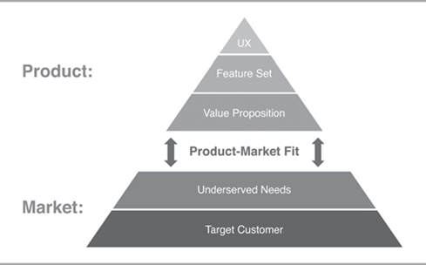

## Why products fail?

There are many reasons why products fail in the market. Here are some common reasons:

1. Lack of market research: If a product is not properly researched before it is launched, it may not meet the needs or wants of its target audience.
2. Poor product design: The design of the product may not be appealing or user-friendly, leading to low adoption rates or high return rates.
3. Insufficient marketing: Even if a product is well-designed, it may not sell if it is not marketed effectively to its target audience.
4. Competition: If there are other products in the market that are similar to the one being offered, the product may fail to gain a foothold.
5. Poor timing: The product may have been launched at the wrong time, such as during an economic downturn or a time when consumer behavior is shifting.
6. Lack of customer support: If customers do not receive the support they need to use the product effectively, they may become frustrated and abandon it.
7. Pricing: If the product is priced too high, it may not be accessible to its target audience. If it is priced too low, it may be perceived as low quality.

It's important to note that not all products fail for the same reasons, and some may fail due to a combination of factors. Successful product management involves identifying potential issues early on and addressing them to ensure the product's success

## What do best product teams do?

The best product teams are able to work together effectively to create successful products that meet the needs and wants of their customers. Here are some things that top product teams do:

1. Focus on the customer: The best product teams put the customer at the center of everything they do. They conduct research to understand the needs and wants of their target audience, and use that information to create products that solve real problems.
2. Set clear goals: The team sets clear, measurable goals for the product, and everyone on the team understands their role in achieving those goals.
3. Collaborate effectively: The team members work together effectively, communicating clearly and openly to ensure that everyone is aligned on the goals and priorities for the product.
4. Iterate and test: The team embraces an iterative approach to product development, testing their assumptions and making changes based on feedback from customers and data.
5. Embrace data: The team uses data to inform their decisions, using metrics to track progress and make data-driven decisions.
6. Focus on quality: The team prioritizes quality, ensuring that the product is well-designed, reliable, and easy to use.
7. Continuously learn: The team is always learning and improving, seeking out feedback and looking for ways to improve their processes and products.

Ultimately, the best product teams are able to create successful products that meet the needs of their customers and drive business growth

## Tackle risks early

There are 4 types of risks:

* Value – Does customer find value in the product
* Usability – Is the product easy to use
* Feasibility – Is the product techically feasible to build
* Viability - Will be business be viable, can we break even

Tackling risks early is an important principle in product management and project management. The idea is to identify potential risks and issues as early as possible in the product development process, so that they can be addressed before they become more difficult or costly to fix.

There are several reasons why it is important to tackle risks early:

1. Save time and resources: By identifying and addressing risks early, companies can avoid wasting time and resources on products that are unlikely to succeed or that require significant rework.
2. Improve product quality: Addressing risks early in the development process can help to improve product quality, as issues can be identified and resolved before they have a chance to impact the final product.
3. Reduce costs: By tackling risks early, companies can reduce costs associated with fixing issues later in the development process or after the product has been released.
4. Improve stakeholder confidence: Early risk identification and mitigation can help to improve stakeholder confidence in the product and the development team, as it demonstrates proactive risk management and a commitment to quality.

To tackle risks early, product managers should prioritize risk identification and assessment throughout the product development process. This may involve conducting regular risk assessments, monitoring key performance indicators, and soliciting feedback from stakeholders and customers. By identifying and addressing risks early, product managers can improve the chances of success for their products and reduce the likelihood of costly issues down the line.

## Product management and rest of the company

Product management is a critical function within a company, and it intersects with many other departments and teams. Here are some ways that product management interacts with the rest of the company:

1. Sales: The product management team works closely with the sales team to understand the needs of customers and ensure that the product meets those needs. They may also provide sales training and support to help the sales team effectively communicate the value of the product to customers.
2. Marketing: The product management team works closely with the marketing team to develop messaging and positioning for the product, as well as marketing strategies to promote it. They may also collaborate on market research to better understand the target audience and inform product development.
3. Engineering: The product management team works closely with the engineering team to ensure that the product is technically feasible and that the development process is efficient and effective. They may also prioritize features and improvements based on customer feedback and market data.
4. Operations: The product management team may work with the operations team to ensure that the product can be manufactured or delivered efficiently and that supply chain logistics are optimized.
5. Customer support: The product management team may work with the customer support team to ensure that customers have the support they need to use the product effectively and address any issues that may arise.

Overall, effective product management requires collaboration and communication with many different departments and teams within the company to ensure that the product is successful in the market.

## Product Lifecycle

The product lifecycle refers to the stages that a product goes through from its initial development to its eventual decline and phase-out. Here are the general stages of the product lifecycle:

1. Development: This is the initial stage of the product lifecycle, where the idea for the product is generated, and the product is developed through design, prototyping, and testing.
2. Introduction: Once the product is developed, it is introduced to the market through marketing and advertising efforts. The company may focus on building awareness and generating demand for the product at this stage.
3. Growth: As the product gains traction in the market, sales and revenue start to increase, and the company may expand production, distribution, and marketing efforts to sustain growth.
4. Maturity: As the product becomes more established in the market, sales growth may start to slow down, and the competition may increase. The company may focus on maintaining market share and increasing profitability by optimizing production and distribution.
5. Decline: Eventually, the product may start to decline in popularity, either due to changes in the market, new technology, or the emergence of newer, better products. At this stage, the company may phase out the product or pivot to a new product offering.

It's important to note that not all products follow this exact path, and some may skip or combine stages depending on their unique circumstances. Additionally, successful companies may continue to innovate and launch new products to stay relevant in the market. Effective product management involves understanding where a product is in its lifecycle and taking appropriate actions to ensure its success

## Technology adoption lifecycle (Crossing the Chasm)

The technology adoption lifecycle, also known as Crossing the Chasm, is a marketing model that explains how new technology products are adopted by customers over time. The model was developed by Geoffrey Moore in his book "Crossing the Chasm: Marketing and Selling High-Tech Products to Mainstream Customers." Here are the key stages of the technology adoption lifecycle:

1. Innovators: Innovators are the first to adopt new technology products. They are risk-takers and are excited about the potential benefits of new technology. They make up about 2.5% of the market.
2. Early Adopters: Early adopters are the next group to adopt new technology products. They are opinion leaders in their social networks and are willing to take risks to be seen as innovative. They make up about 13.5% of the market.
3. Early Majority: The early majority is a more pragmatic group that waits until new technology products have been proven in the market before adopting them. They make up about 34% of the market.
4. Late Majority: The late majority is a group that is skeptical of new technology and adopts products only when they have become mainstream. They make up about 34% of the market.
5. Laggards: Laggards are the last group to adopt new technology products. They are resistant to change and may continue using outdated technology long after it has been replaced by newer, more advanced products. They make up about 16% of the market.

The challenge for companies is to "cross the chasm" from the early adopters to the early majority. This requires a different marketing strategy than that used to appeal to innovators and early adopters. Companies need to focus on building credibility and creating a compelling value proposition that appeals to the practical needs of the early majority. They may need to modify their products or marketing messaging to appeal to this group, as they have different needs and preferences than early adopters. Ultimately, the goal is to make the technology product mainstream and achieve widespread adoption

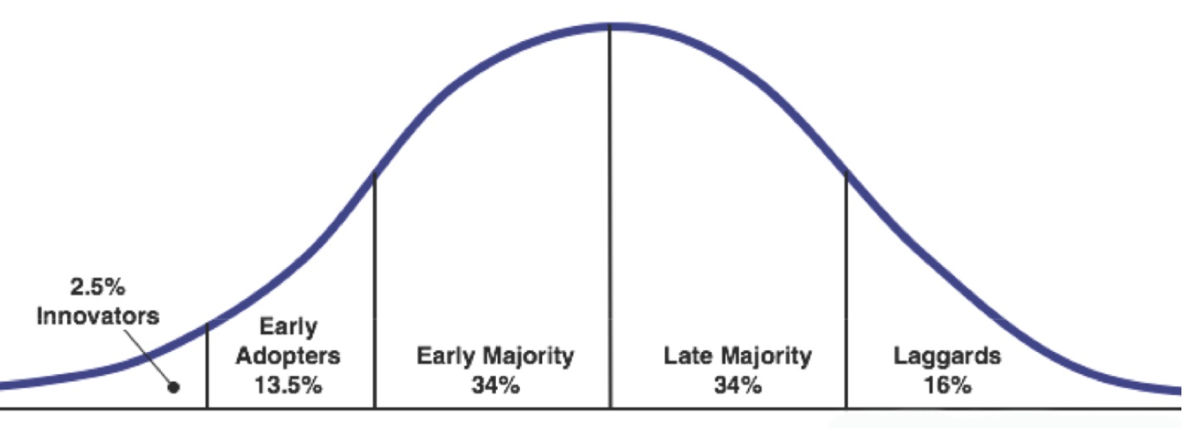

## Journey of some product companies – Netflix, Google, Microsoft (Internet)

Here is a brief overview of the journey of three well-known internet product companies - Netflix, Google, and Microsoft:

1. Netflix:

Netflix started as a DVD-by-mail service in 1997 and quickly grew in popularity, becoming one of the largest DVD rental services in the US. In 2007, Netflix launched its online streaming service, which enabled subscribers to stream movies and TV shows on-demand. The company quickly transitioned its business model to focus on streaming and started producing original content. Today, Netflix is one of the leading online streaming services, with over 200 million subscribers worldwide.

1. Google:

Google was founded in 1998 as a search engine. In 2000, the company launched its first advertising program, AdWords, which allowed businesses to place targeted ads on Google's search results pages. Google quickly became the dominant search engine and expanded its services to include email (Gmail), online productivity tools (Google Docs), and mobile operating systems (Android). Today, Google is one of the world's largest technology companies, with a market cap of over $1 trillion.

1. Microsoft:

Microsoft was founded in 1975 and initially focused on developing operating systems and productivity software for personal computers. In the 1990s, Microsoft dominated the personal computer market with its Windows operating system and Office productivity suite. In the 2000s, Microsoft expanded into gaming (Xbox), search (Bing), and cloud computing (Azure). Today, Microsoft is one of the world's largest technology companies, with a market cap of over $2 trillion.

Each of these companies has undergone significant transformations over the years, adapting to changing market conditions and evolving technologies. They have all managed to stay relevant and successful by innovating and expanding their product offerings to meet the needs of their customers

## Multi-faceted role of a Product manager (Inspired, Product leadership)

The role of a product manager is multi-faceted, as they are responsible for driving the success of a product or product line. Here are some key responsibilities and skills of a product manager, as described in the books "Inspired" by Marty Cagan and "Product Leadership" by Richard Banfield, Martin Eriksson, and Nate Walkingshaw:

1. Vision and Strategy: Product managers must be able to define a clear product vision and strategy that aligns with the overall business goals. They need to have a deep understanding of the market, the customer needs, and the competition, and be able to articulate how the product will address these factors.
2. Roadmap Planning: Product managers are responsible for developing a product roadmap that outlines the key milestones and features that will be delivered over time. They must prioritize features based on customer needs, market demand, and business goals.
3. Cross-Functional Collaboration: Product managers need to work closely with cross-functional teams, including design, engineering, marketing, and sales, to ensure that the product is developed and launched successfully. They need to have excellent communication skills and be able to facilitate collaboration and consensus-building.
4. Product Development Process: Product managers must be knowledgeable about the product development process, including agile methodologies, product testing, and user research. They need to ensure that the product is developed efficiently and effectively, and that the development process is transparent and well-documented.
5. Data-Driven Decision Making: Product managers need to be able to use data to make informed decisions about the product, including user feedback, customer behavior, and market trends. They must be able to analyze data and derive insights that inform product decisions.
6. Leadership and Team Building: Product managers need to be strong leaders who can inspire and motivate their teams to achieve the product goals. They must be able to hire, train, and manage their team members effectively, and provide feedback and coaching to help them improve.

In summary, the role of a product manager is complex and multifaceted, requiring a combination of technical, business, and leadership skills. Product managers must be able to drive the success of a product by developing a clear vision and strategy, prioritizing features based on customer needs, collaborating with cross-functional teams, and making data-driven decisions. They must also be strong leaders who can motivate and inspire their teams to achieve the product goals.

# Core concepts

## Principles of product management

Product management is a complex and multifaceted discipline, but there are some fundamental principles that are essential for success. Here are some key principles of product management:

1. Customer Focus: A successful product manager must have a deep understanding of the customer and their needs. They must be able to listen to feedback, identify customer pain points, and translate those insights into product features and improvements.
2. Cross-Functional Collaboration: Product management involves working with a wide range of stakeholders, including engineers, designers, sales teams, and executives. A successful product manager must be able to collaborate effectively across these teams, communicate clearly, and drive alignment around product goals.
3. Strategic Thinking: Product managers must be able to think strategically about the long-term vision for the product, the market, and the company. They must be able to prioritize initiatives, identify new opportunities, and make tough trade-offs to ensure that the product is successful over the long term.
4. Data-Driven Decision Making: Product managers must be able to use data to make informed decisions about product features, pricing, and other key aspects of the product. They must be able to gather and analyze data, identify trends and insights, and use that information to make smart decisions.
5. Agile and Iterative Development: Product management involves a continuous process of ideation, development, testing, and iteration. Product managers must be able to work in an agile and iterative way, quickly adapting to new information and feedback to ensure that the product is meeting customer needs and delivering value.
6. Results Orientation: Product managers must be focused on delivering results for the company and for the customer. They must be able to set clear goals, measure progress, and adjust strategies and tactics as needed to ensure that the product is successful.

These are just some of the key principles of product management. Successful product managers must be able to apply these principles in a dynamic and constantly evolving environment, adapting to new challenges and opportunities as they arise

## Aspects of a product – a holistic definition

A product can be defined as a combination of various elements that work together to deliver value to the customer. Here are some of the key aspects of a product that should be considered when defining it holistically:

1. Core Functionality: This is the primary benefit that the product delivers to the customer. It is the reason why the customer is willing to buy the product in the first place.
2. Features: These are the specific capabilities and functionalities that the product offers to the customer. Features are designed to enhance the core functionality and make the product more appealing and useful.
3. Design: The design of the product includes both the physical appearance and the user interface. A well-designed product should be easy to use, visually appealing, and provide a positive user experience.
4. Quality: The quality of the product is a critical aspect of its success. Customers expect products to be reliable, durable, and free from defects or issues.
5. Branding: The brand of the product is an important factor in how it is perceived by customers. Strong branding can help differentiate the product from competitors and build customer loyalty.
6. Packaging: The packaging of the product is an important element of its marketing and can impact customer perception of the product.
7. Pricing: The price of the product is a key factor in whether customers will choose to purchase it. The price should be competitive and reflect the value that the product delivers.
8. Distribution: The way that the product is distributed and made available to customers is an important consideration. This includes factors such as the channels through which the product is sold and the availability of the product in different markets.
9. Support: The level of customer support provided for the product can be a key factor in customer satisfaction and loyalty.

All of these aspects of a product work together to create a holistic definition of what the product is and how it delivers value to the customer. Successful product management requires a deep understanding of each of these aspects and how they interact with one another.

## Product-Market fit (LPP)

Product-market fit is a concept that refers to the alignment between a product and the market it serves. It is a critical factor in the success of a product and a company. Product-market fit means that the product satisfies the needs and preferences of the target market and delivers value that the market is willing to pay for.

The Lean Product Process (LPP) is a framework that can be used to achieve product-market fit. The LPP consists of five stages:

1. Problem/Solution Fit: In this stage, the focus is on understanding the problem that the product is trying to solve and identifying a solution that meets the needs of the target market.
2. Minimum Viable Product (MVP): The MVP is a simplified version of the product that includes only the core features necessary to test the solution with customers.
3. Product/Market Fit: This stage involves refining the product based on feedback from customers and testing to ensure that it is meeting the needs of the target market.
4. Scaling the Product: Once product-market fit has been achieved, the focus shifts to scaling the product to reach a wider audience.
5. Growth: In this final stage, the focus is on accelerating growth and maximizing the value that the product delivers to the market.

The LPP provides a structured approach to achieving product-market fit, with an emphasis on continuous learning and iteration based on feedback from customers. By following the LPP, product teams can increase their chances of success by creating products that meet the needs of the market and deliver value to customers.

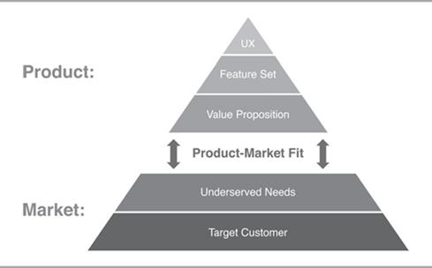

## Problem space vs Solution space

Problem space and solution space are two distinct and important concepts in product management.

The problem space refers to the set of problems that a product is designed to solve. This includes understanding the needs and pain points of the target market, as well as the broader context in which the product will be used. The problem space is about identifying the right problems to solve, and ensuring that the product addresses those problems in a way that is valuable to the market.

The solution space, on the other hand, refers to the set of possible solutions to the problems identified in the problem space. This includes the features, functionality, and user experience of the product. The solution space is about designing and building a product that effectively solves the identified problems.

While the problem space and solution space are related, they require different approaches and skill sets. The problem space requires empathy and research to deeply understand the needs of the market, while the solution space requires creativity and technical expertise to design and build effective solutions.

It's important for product teams to balance their focus between the problem space and solution space. Focusing too much on the solution space without a clear understanding of the problem space can lead to building a product that doesn't meet the needs of the market. Conversely, focusing too much on the problem space without developing effective solutions can lead to a lack of execution and failure to deliver value to customers

## User vs buyer

User and buyer are two different roles that are involved in the consumption of a product.

The user is the person who actually uses the product to fulfill their needs or solve their problems. They interact with the product and its features and ultimately determine whether the product meets their needs or not. For example, in the case of a software product, the user would be the person who actually uses the software to perform their tasks.

The buyer, on the other hand, is the person or entity that purchases the product. They may or may not be the same person as the user. In some cases, the buyer and user may be the same person, but in other cases, they may be different. For example, a parent may purchase a toy for their child, but the child is the one who actually uses the toy.

It's important for product teams to consider both the user and buyer when developing and marketing their products. The needs and preferences of the user may be different from those of the buyer, and addressing both can lead to a more successful product. For example, a product may have features that are attractive to the user but may not be a priority for the buyer. In this case, the product team may need to find ways to communicate the value of those features to the buyer in order to make the sale

## Continuous discovery and delivery

Continuous discovery and delivery are two important practices in modern product development.

Continuous discovery is the process of continuously learning about customers, their needs, and the market in which the product operates. This involves using a variety of methods such as user research, customer interviews, and analytics to gather data and insights about the target audience. The goal of continuous discovery is to inform the product development process, ensuring that the product meets the needs of customers and provides value to the market.

Continuous delivery, on the other hand, is the practice of continuously releasing new features and updates to the product. This involves using agile methodologies and automated testing and deployment tools to quickly and efficiently deploy changes to the product. The goal of continuous delivery is to get new features and updates into the hands of users as quickly as possible, allowing the product to evolve and improve over time.

By combining continuous discovery and delivery, product teams can ensure that they are building products that meet the needs of their customers and the market, and are delivering those products quickly and efficiently. This can help to improve the success of the product and the overall satisfaction of customers

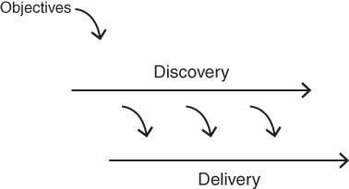

## Product eco-system

A product ecosystem refers to the network of products and services that work together to create a complete solution for the customer. It includes all the components that surround a product, such as hardware, software, accessories, services, and third-party integrations. The ecosystem is designed to provide a seamless experience for the customer, enabling them to achieve their desired outcomes.

A well-designed product ecosystem can provide many benefits, such as increased customer satisfaction, loyalty, and engagement. It can also provide a competitive advantage by creating a barrier to entry for competitors, as it can be difficult to replicate a fully integrated ecosystem.

An example of a successful product ecosystem is Apple's ecosystem of products, which includes the iPhone, iPad, Mac, Apple Watch, AirPods, and other accessories. These products work together seamlessly, allowing customers to easily transfer files, use the same apps across devices, and access content from anywhere. Apple also provides a range of services such as iCloud, iTunes, and the App Store, which further enhance the ecosystem.

Creating a product ecosystem requires careful planning and coordination across different teams and stakeholders. It involves not only developing a strong core product, but also integrating with other products and services to create a complete solution that meets the needs of customers.

## Critical success factors

Critical success factors (CSFs) are the key factors that must be achieved for a project, program, or organization to be successful. These factors are critical because they have a direct impact on the success or failure of the initiative. CSFs are typically identified during the planning phase of a project or program and are used to guide decision-making and prioritize actions.

The specific CSFs will vary depending on the context of the project or program, but there are some common factors that are often critical to success, such as:

1. Clear goals and objectives: It is important to have a clear understanding of what the project or program is trying to achieve and how success will be measured.
2. Strong leadership: A strong and effective leader is essential for driving the project or program forward, managing stakeholders, and ensuring that resources are used effectively.
3. Skilled and motivated team: A skilled and motivated team is critical to the success of any project or program. It is important to have the right people with the right skills in place and to create an environment that supports and motivates them.
4. Effective communication: Effective communication is essential for ensuring that everyone involved in the project or program is aligned and working towards the same goals. It is important to communicate clearly and frequently, and to listen to feedback and concerns from stakeholders.
5. Robust risk management: It is important to identify potential risks and develop plans to mitigate them. This involves identifying the risks, assessing their likelihood and impact, and developing plans to manage them if they occur.
6. Adequate resources: Adequate resources, including funding, personnel, and technology, are critical for achieving success. It is important to ensure that the resources are available when needed and that they are used effectively.

By identifying and prioritizing critical success factors, project or program managers can focus their efforts on the areas that are most important for achieving success. This helps to ensure that the project or program is on track and that resources are being used effectively

# Product process

## Overview of the process (Inspired + Lean Startup)

The process of developing successful products involves several key stages, which can be broadly categorized as:

1. Problem Discovery: This stage involves identifying and validating a real problem that customers face. It involves conducting customer research, analyzing market trends, and identifying pain points that customers experience.
2. Solution Ideation: Once a problem is identified, the next step is to brainstorm potential solutions. This stage involves generating ideas, prototyping and testing solutions, and selecting the best one to pursue.
3. Product Development: This stage involves designing and building the product, including developing the features and functionality, creating the user interface, and testing the product for usability and functionality.
4. Product Launch: This stage involves bringing the product to market, including developing a marketing plan, identifying and targeting potential customers, and building a distribution network.
5. Growth and Scaling: Once the product is launched, the focus shifts to growing and scaling the business. This stage involves tracking key metrics, such as customer acquisition and retention, and optimizing the product and business model to achieve sustainable growth.

Throughout this process, it's important to continuously gather feedback from customers and stakeholders, and to use this feedback to inform decisions and make course corrections as needed. The Lean Startup methodology emphasizes the importance of building, measuring, and learning iteratively, and using data to inform decision-making. The Inspired Product Management framework emphasizes the importance of aligning product development with business goals, and of focusing on creating valuable and usable products that solve real customer problems.

## Build-Measure-Learn cycle

The Build-Measure-Learn (BML) cycle is a process used in product development to validate assumptions and hypotheses by building a minimum viable product (MVP), measuring its performance, and learning from customer feedback to make data-driven decisions. The BML cycle is a key component of the Lean Startup methodology and is based on the scientific method of hypothesis testing.

Here are the steps involved in the BML cycle:

1. Build: Develop an MVP that solves a customer problem or meets a customer need. The MVP should be the simplest version of the product that can be built to test the hypothesis.
2. Measure: Collect data on how the MVP is being used and how it is performing. This could involve user engagement metrics, such as how many people are using the product and how often, as well as product performance metrics, such as how quickly the product is responding to user inputs.
3. Learn: Analyze the data collected in the Measure step to validate or invalidate the hypothesis. Use this data to identify what is working and what needs to be improved.
4. Pivot: Based on the data and insights gained from the previous steps, make strategic changes to the product, business model, or customer segment. Pivot to a new direction if necessary, or continue with incremental improvements.
5. Repeat: Continuously iterate through the BML cycle, building and improving the product based on customer feedback until the product-market fit is achieved.

By following the BML cycle, product teams can create products that customers truly want and need, while avoiding the waste of time and resources on features and functions that do not add value.

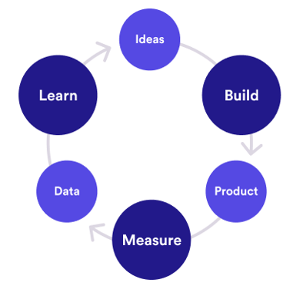

## Identify opportunity

### Identifying underserved customer needs (LPP)

Identifying underserved customer needs is a critical step in product management. Here are some steps to identify underserved customer needs:

1. Conduct Market Research: Start by conducting market research to understand your target audience and their needs. Use surveys, focus groups, and interviews to gather information about their pain points, frustrations, and unmet needs.
2. Identify Customer Personas: Create customer personas based on your market research to better understand your target audience. These personas should include demographic information, behaviors, and goals.
3. Analyze Competition: Analyze your competitors and identify gaps in the market. Look for opportunities to differentiate your product and meet the needs of underserved customer segments.
4. Use Data Analytics: Use data analytics to gain insights into customer behavior and identify trends. Look for patterns in customer data that can help you understand their needs and preferences.
5. Conduct User Testing: Conduct user testing to gather feedback from customers on your product. Use this feedback to improve your product and identify any gaps in your understanding of customer needs.
6. Iterate and Improve: Use the insights gained from customer research, market analysis, and user testing to iterate and improve your product. Continuously refine your product to better meet the needs of your customers.

By following these steps, you can identify underserved customer needs and develop a product that meets those needs, giving you a competitive advantage in the market.

### Sources of innovation (Peter Drucker)

Peter Drucker, a renowned management consultant, identified several sources of innovation in his book "Innovation and Entrepreneurship." These sources include:

1. The unexpected: Innovations can come from unexpected events, such as accidents or mistakes, that reveal new possibilities or solutions.
2. Incongruities: Innovations can arise from the mismatch or gap between what is and what should be, such as a discrepancy between customer needs and existing products or services.
3. Process needs: Innovations can stem from the need to improve or streamline processes, such as manufacturing or distribution, to increase efficiency or reduce costs.
4. Industry and market changes: Innovations can emerge from changes in the market or industry, such as new regulations, emerging technologies, or shifts in customer preferences.
5. Demographic changes: Innovations can result from changes in demographics, such as the aging population, which creates new needs and opportunities for products and services.
6. Changes in perception: Innovations can arise from changes in how people perceive things, such as new trends, cultural shifts, or changing attitudes.
7. New knowledge: Innovations can come from new scientific or technological breakthroughs, such as the discovery of new materials or the invention of new technologies.
8. The challenge of new ventures: Innovations can emerge from the challenges of starting a new venture, such as the need to create new business models or find new markets.

Drucker's sources of innovation provide a framework for identifying opportunities and generating new ideas for products and services

### Hack days (Inspired)

Hack days, also known as hackathons, are events where a group of people, often from different backgrounds and expertise, come together to collaboratively work on solving a problem or developing a new product or service. These events typically take place over a period of one or more days and involve intense periods of brainstorming, ideation, and rapid prototyping.

Hack days can be a valuable tool for fostering innovation and creativity within an organization. They provide an opportunity for employees to step outside of their usual roles and work on new and exciting projects. By bringing together people with different skills and perspectives, hack days can also encourage collaboration and cross-functional learning.

In the book "Inspired: How to Create Tech Products Customers Love", author Marty Cagan recommends using hack days as a way to explore new product ideas and identify customer needs. He suggests that hack days can be particularly useful for identifying underserved customer needs, as participants are encouraged to think creatively and experiment with new approaches.

Overall, hack days can be an effective way to generate new ideas and foster innovation within an organization. However, it's important to approach them with a clear goal in mind and to ensure that the results of the event are properly evaluated and integrated into the product development process

### Ideation techniques (Cooper & Edgett)

Cooper and Edgett have outlined several ideation techniques in their book "Product Innovation and Technology Strategy." Here are some of the ideation techniques:

1. Brainstorming: A group technique for generating a large number of ideas in a short period of time.
2. Mind mapping: A visual technique that involves the use of a diagram to represent ideas and their relationships.
3. SCAMPER: A structured approach to ideation that involves asking questions about how to modify or adapt existing products or services.
4. Attribute listing: A technique that involves breaking down a product or service into its component attributes and then generating ideas for improving each attribute.
5. Forced relationships: A technique that involves connecting unrelated concepts or objects to generate new ideas.
6. Analogies: A technique that involves using analogies or metaphors to generate new ideas.
7. Morphological analysis: A technique that involves breaking down a product or service into its component parts and then generating new combinations of these parts to create new products or services.
8. TRIZ: A structured approach to problem-solving that involves the use of a matrix of contradictions to identify innovative solutions.

These are just a few of the ideation techniques that can be used to generate new product ideas. It's important to choose the right technique for the problem you are trying to solve and to involve a diverse group of stakeholders in the ideation process

## Assess the opportunity (Inspired – Product discovery)

Assessing the opportunity is a crucial step in product discovery, as it helps product managers to determine whether or not a potential opportunity is worth pursuing. Here are some key steps and considerations in assessing the opportunity:

1. Identify the problem: Start by clearly identifying the problem or pain point that the potential opportunity is trying to solve. This can involve conducting customer interviews, surveys, or other forms of research to gain a deep understanding of the customer's needs and pain points.
2. Assess the market: Next, assess the size and growth potential of the market for the potential opportunity. This can involve researching competitors and analyzing market trends to determine whether there is a viable market for the product.
3. Evaluate the competition: Evaluate the strengths and weaknesses of potential competitors, including their market position, product features, pricing, and marketing strategies.
4. Analyze the business case: Develop a business case to determine whether the potential opportunity is financially feasible. This can involve assessing the costs of developing and launching the product, as well as estimating potential revenue and profitability.
5. Consider the risks: Finally, consider the risks associated with pursuing the opportunity, including technical, market, and financial risks. Develop strategies for mitigating these risks and ensuring that the product has the best chance of success.

Overall, assessing the opportunity is a critical step in product discovery that can help product managers to determine whether or not to pursue a potential opportunity and to develop a successful product that meets customer needs and achieves business goals

### Define value proposition

A value proposition is a statement that explains how a product or service solves a customer's problem or fulfills a customer's need in a unique and compelling way. It articulates the specific benefits that a customer can expect to receive from using the product or service, and how those benefits differ from those offered by competitors. A well-crafted value proposition should be clear, concise, and easily understood by the target customer. It should also be supported by evidence and data that demonstrates the product or service's value and effectiveness. The value proposition is a key component of product strategy and is critical for driving customer acquisition and retention.

### Assess the value of the product

Assessing the value of a product is an important step in the product development process. It involves determining the benefits that the product will provide to its users and the market, as well as the potential return on investment for the business.

Here are some steps to assess the value of a product:

1. Define the problem the product will solve: Identify the problem that your product is trying to solve. This could be a pain point that users are experiencing or a gap in the market that you are trying to fill.
2. Define the target audience: Identify the users who are most likely to benefit from your product. This includes understanding their needs, preferences, and behaviors.
3. Determine the unique value proposition: Determine what sets your product apart from competitors in the market. This could be a unique feature, a different pricing model, or a better user experience.
4. Evaluate market size and potential: Determine the size of the market that your product is targeting and the potential for growth. This involves conducting market research and analyzing industry trends.
5. Analyze the competitive landscape: Identify the competitors in your market and evaluate their strengths and weaknesses. This will help you identify areas where your product can differentiate itself.
6. Determine the financial viability: Assess the financial viability of the product by analyzing the costs of development and production, as well as the potential revenue streams.
7. Test and refine: Finally, test your product with users and use feedback to refine your value proposition and product features.

By following these steps, you can assess the value of your product and determine its potential for success in the market

### Risks assessment – Value risk, Usability risk, Technical feasibility risk & Business viability risk

When assessing the risks associated with a product, there are several key areas to consider. These include:

1. Value Risk: This refers to the risk that the product may not deliver the expected value to the customer. To assess this risk, you can ask questions like:

* What are the customer needs and expectations for this product?
* How does the product address those needs and expectations?
* Are there alternative products that customers may prefer?
* What is the potential market size for this product?
* What are the potential revenue streams for this product?

1. Usability Risk: This refers to the risk that the product may be difficult to use or understand, leading to poor user adoption and satisfaction. To assess this risk, you can ask questions like:

* Is the product intuitive and easy to use?
* Does it have a clear user interface?
* Are there any potential usability issues that need to be addressed?
* What are the user feedback and reviews on similar products in the market?
* What are the pain points that the product is addressing?

1. Technical Feasibility Risk: This refers to the risk that the product may not be feasible from a technical perspective. To assess this risk, you can ask questions like:

* Is the product technically feasible given the available resources?
* What are the technical risks associated with developing and launching the product?
* Are there any technical limitations that need to be addressed?
* What is the level of complexity in developing the product?
* What is the technological trend for the market?

1. Business Viability Risk: This refers to the risk that the product may not be financially viable in the long term. To assess this risk, you can ask questions like:

* What are the costs associated with developing, launching, and maintaining the product?
* How does the product generate revenue?
* What is the pricing strategy for the product?
* What is the potential return on investment (ROI) for the product?
* What are the potential barriers to entry for competitors in the market?

By considering these risks, product managers can make informed decisions about the viability and potential success of a product

## Create business plan – Start-up canvas

The start-up canvas is a visual tool used to outline the key components of a business plan. It is a one-page document that provides an overview of the start-up's value proposition, customer segments, revenue streams, key activities, resources, partners, cost structure, and channels.

Here is a brief overview of each component of the start-up canvas:

1. Value proposition: This is a statement that describes the unique value that the start-up offers to its customers. It should be clear, concise, and address a specific customer need.
2. Customer segments: This section outlines the different groups of customers that the start-up is targeting. It is important to understand the needs, behaviors, and characteristics of each customer segment.
3. Revenue streams: This section outlines how the start-up plans to generate revenue. This could include sales of products or services, subscription fees, or advertising revenue.
4. Key activities: This section outlines the core activities that the start-up must undertake to create and deliver its value proposition. This could include product development, marketing and sales, or customer support.
5. Resources: This section outlines the resources that the start-up needs to undertake its key activities. This could include physical resources such as equipment and facilities, or intangible resources such as intellectual property.
6. Partners: This section outlines the key partners that the start-up needs to work with to create and deliver its value proposition. This could include suppliers, distributors, or strategic partners.
7. Cost structure: This section outlines the costs associated with running the start-up. This could include expenses related to product development, marketing and sales, or overhead costs.
8. Channels: This section outlines the different channels that the start-up will use to reach its customers. This could include direct sales, online advertising, or social media marketing.

Overall, the start-up canvas is a useful tool for entrepreneurs to develop a clear and concise business plan. It can be updated and refined as the start-up grows and evolves.

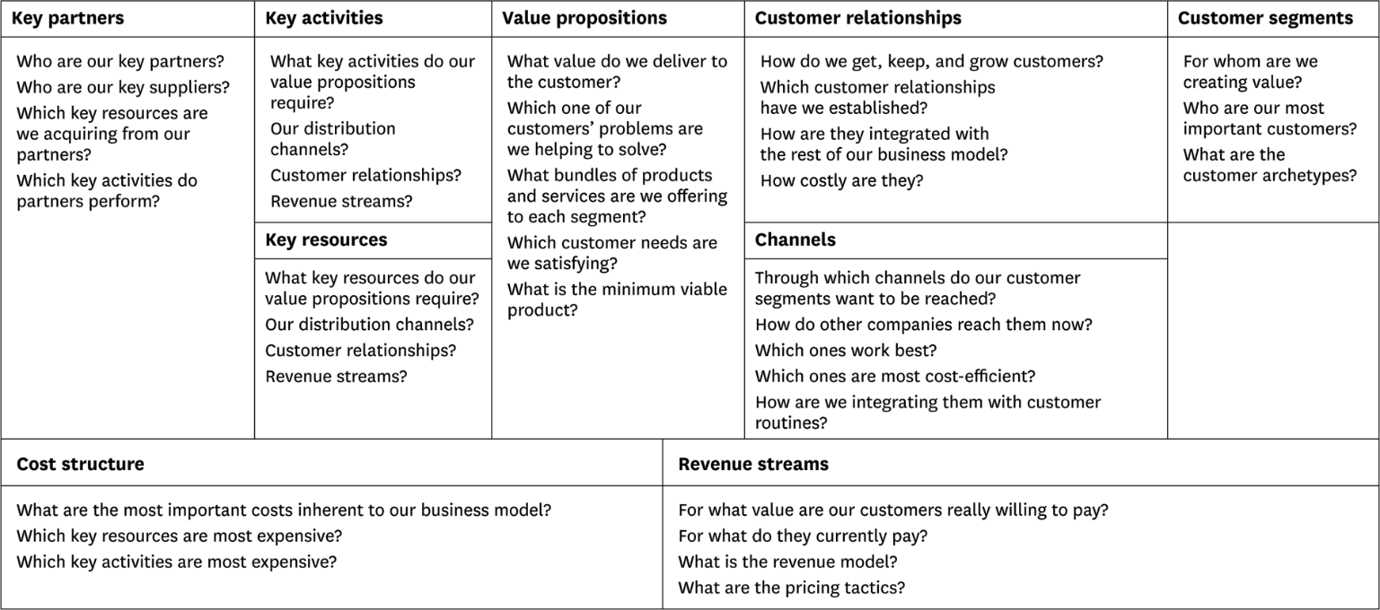

# Story map

A story map is a visual tool used in product development to organize and prioritize user stories or product features. It consists of a series of vertical columns representing different stages of the user journey or product development, and horizontal rows representing the various user personas or customer segments.

The story map helps product teams to identify and prioritize the most important user stories or features, and to understand how they fit into the overall product vision and strategy. It also helps to ensure that the product development effort is aligned with the user needs and goals.

Story mapping typically starts with a high-level view of the product or user journey, and then drills down into more detail as the product team iterates and refines the product backlog. The process of story mapping is highly collaborative, involving input from the entire product team as well as stakeholders such as customers, partners, and subject matter experts.

Story maps can be used in various stages of product development, from early ideation and discovery to post-launch optimization and enhancement. They can be created on a physical whiteboard or using digital tools such as online collaboration platforms or specialized story mapping software.

### Capturing features using Story Map

Story mapping is a technique used in product development to capture and organize features or user stories based on their priority and relationship to each other. Here is a step-by-step process for capturing features using a story map:

1. Identify the target user or persona: Determine who the product is for and what their needs and goals are.
2. Define the high-level product goals: Define the main objectives or outcomes that the product should achieve.
3. Break down the goals into activities: Break down the goals into smaller activities or tasks that users need to complete to achieve the goals.
4. Group activities into themes: Group the activities into themes based on their similarities or relationships.
5. Prioritize the themes: Prioritize the themes based on their importance to the product goals and the user needs.
6. Define the user stories for each theme: For each theme, define the user stories that represent the features or functionality required to accomplish the activities.
7. Map the stories to the themes: Map the user stories to the themes they belong to, and organize them in a logical sequence.
8. Determine the priority of the stories: Determine the priority of the stories based on their importance to the product goals, user needs, and technical feasibility.
9. Refine the story map: Continuously refine the story map as new information becomes available or as the product evolves.

By capturing features using a story map, product teams can create a visual representation of the product backlog, prioritize features based on their value, and ensure that the product development efforts are aligned with the user needs and goals

### Release planning using Story Map

Release planning using Story Map involves using the visual representation of the user journey to plan the sequence of features that will be delivered in each release of the product. This process helps product managers to prioritize features and ensure that the product is developed in a way that aligns with the user's needs.

To create a release plan using Story Map, follow these steps:

1. Break down the user journey into small, manageable steps that represent the user's interaction with the product. These steps will serve as the backbone of the Story Map.
2. Organize the steps into columns based on the priority level of each step. The most important steps should be placed in the first column, and the least important steps should be placed in the last column.
3. Identify the features that are required to support each step of the user journey. These features should be added as cards under each step.
4. Prioritize the features based on their importance and relevance to the user journey. The most important features should be placed at the top of each column, and the least important features should be placed at the bottom.
5. Determine the dependencies between features and identify any technical or business constraints that may impact the delivery of the features.
6. Use the Story Map to plan the sequence of releases for the product. Start with the features that are most critical to the user journey and plan to deliver them in the first release. Then, move on to the next set of features and plan to deliver them in subsequent releases.
7. Use the release plan to communicate the development roadmap to stakeholders and to guide the development team's work.

By following these steps, product managers can use Story Map to create a release plan that is closely aligned with the user's needs and delivers value to the customer in each release.

### Prioritizing features using Kano model

The Kano model is a prioritization framework that helps product managers identify and categorize features based on their impact on customer satisfaction. The framework was developed by Professor Noriaki Kano in the 1980s and is widely used in product management.

The Kano model categorizes features into three categories:

1. Must-Have Features: These are features that are essential for the product to function as intended. Customers expect these features to be present and take them for granted. If a must-have feature is missing, customers will be highly dissatisfied.
2. Performance Features: These are features that improve the performance of the product and increase customer satisfaction. The more of these features a product has, the more satisfied customers will be. However, there is a point of diminishing returns, after which adding more performance features does not increase customer satisfaction significantly.
3. Delight Features: These are unexpected features that go above and beyond what customers expect. They are not essential, but they can delight customers and create a strong emotional connection with the product. Delight features can differentiate a product from its competitors and create customer loyalty.

To prioritize features using the Kano model, product managers should categorize each feature into one of the three categories and then prioritize them accordingly. Must-have features should be implemented first, followed by performance features. Delight features should be added last, as they are not essential and can be expensive to implement.

Product managers can use customer surveys or focus groups to determine which features fall into which category. They can then use this information to prioritize features and plan their product roadmap accordingly

### Story map: Job portal

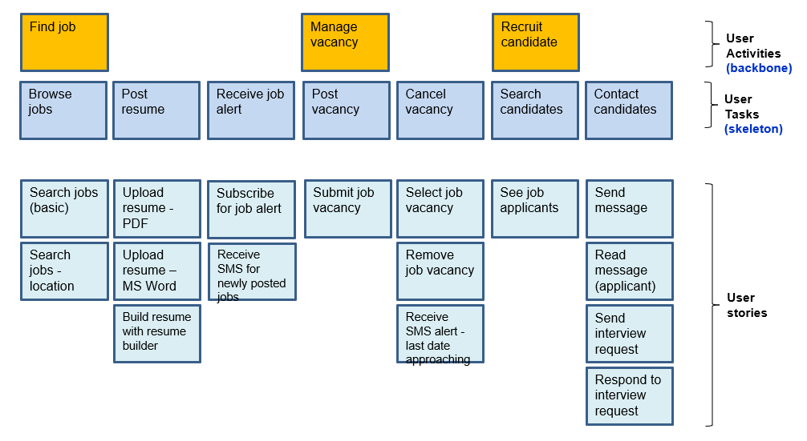

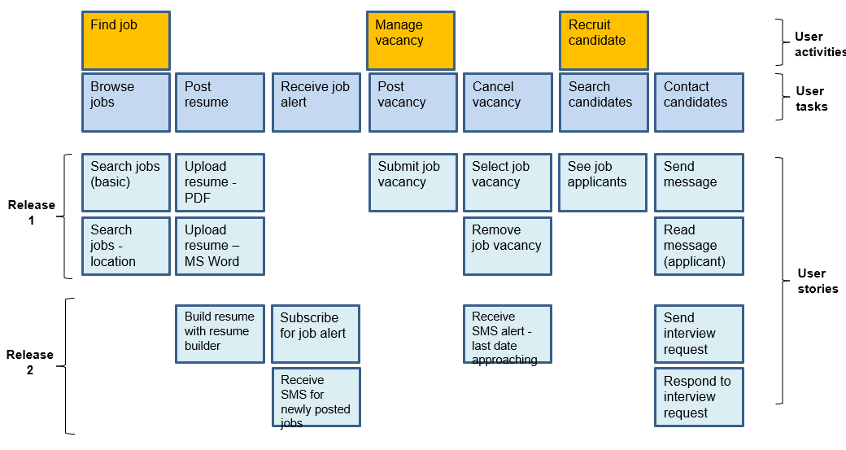

### Story map: Hotel booking software

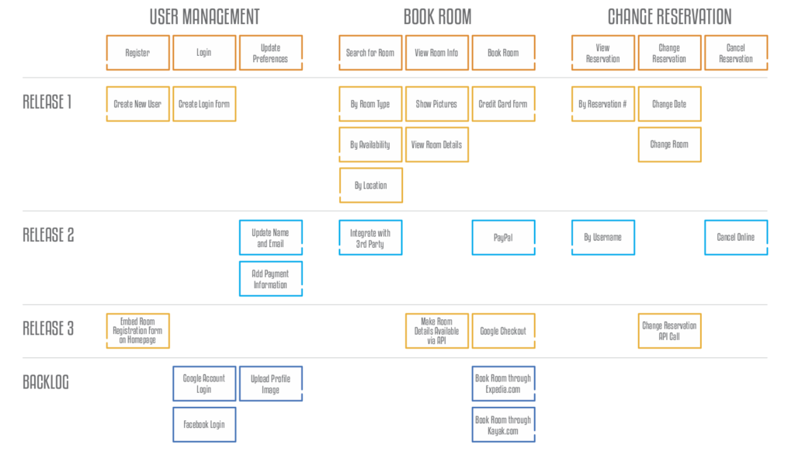

### Story map: Email system

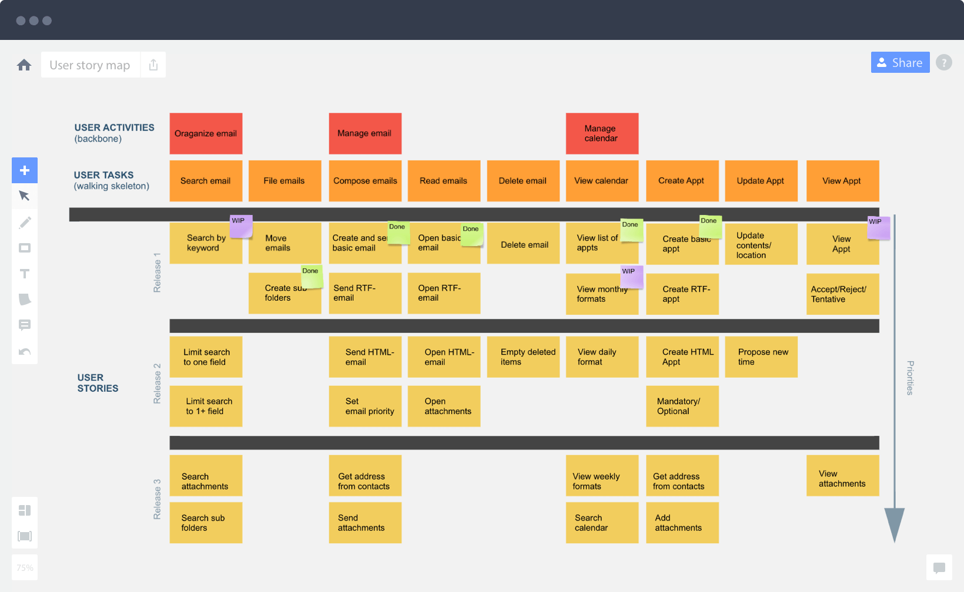

## Create Minimum Viable Product (MVP) (LPP)

Creating a Minimum Viable Product (MVP) is an essential step in the product development process, especially for startups and new products. An MVP is a product with just enough features to satisfy early customers and to provide feedback for future product development. Here are some steps to create an MVP:

1. Define the problem: Start by identifying the problem you want to solve. Talk to potential customers, understand their needs, and identify the key pain points. This will help you to create a product that solves a real problem and has a market demand.
2. Identify key features: After identifying the problem, define the key features that are essential to solving the problem. Prioritize the features based on their importance and the impact they have on solving the problem.
3. Build a prototype: Once you have identified the key features, build a prototype that includes those features. The prototype should be functional enough to demonstrate the product's value and allow users to provide feedback.
4. Test with early adopters: After building the prototype, test it with early adopters who are likely to be your target market. This will help you to gather feedback and identify any issues that need to be addressed before launching the product.
5. Refine the product: Use the feedback from early adopters to refine the product. Focus on improving the key features that have the most impact on solving the problem. Iterate until you have a product that satisfies early customers and provides a foundation for future development.
6. Launch the MVP: Once you have refined the product, launch the MVP. This will allow you to validate your assumptions and test the product's market demand. Gather feedback from early customers and use it to continue improving the product.

Remember, the goal of an MVP is to test your assumptions, gather feedback, and validate the product's value proposition. It is not meant to be a complete product or a final version

### What is MVP?

MVP stands for Minimum Viable Product, which is a version of a product with enough features to satisfy early customers and to provide feedback for future product development. The concept of MVP is often used in agile software development and product management to create a product that can be launched quickly and with minimal resources, while still providing value to customers. MVPs are designed to test hypotheses about the product and the market, and to gather feedback that can be used to improve the product before a full-scale launch. By launching an MVP, product teams can validate assumptions, reduce the risk of failure, and optimize the product development process.

### MVP types

There are different types of MVPs that can be created depending on the needs of the product and the target audience. Some common types of MVPs are:

1. Concierge MVP: This type of MVP involves providing a personalized experience to a small group of users. The product is manually delivered, and the feedback is used to refine the product.
2. Wizard of Oz MVP: This type of MVP simulates a fully functional product using manual processes behind the scenes. It is used to test the demand for a product before investing in development.
3. Piecemeal MVP: This type of MVP involves building only the essential features of a product and outsourcing the rest to third-party services or tools. It is useful for testing the demand for a product without investing heavily in development.
4. Landing Page MVP: This type of MVP involves creating a landing page that describes the product and its features. Users are then directed to a waiting list or a survey to gauge interest in the product.
5. Prototype MVP: This type of MVP involves creating a basic prototype of the product with limited functionality. It is used to test the core features of a product before investing in development.
6. Smoke Test MVP: This type of MVP involves creating a simple landing page that describes the product and its features. Users are then directed to a purchase page or a survey to gauge interest in the product.

### When to use which MVP

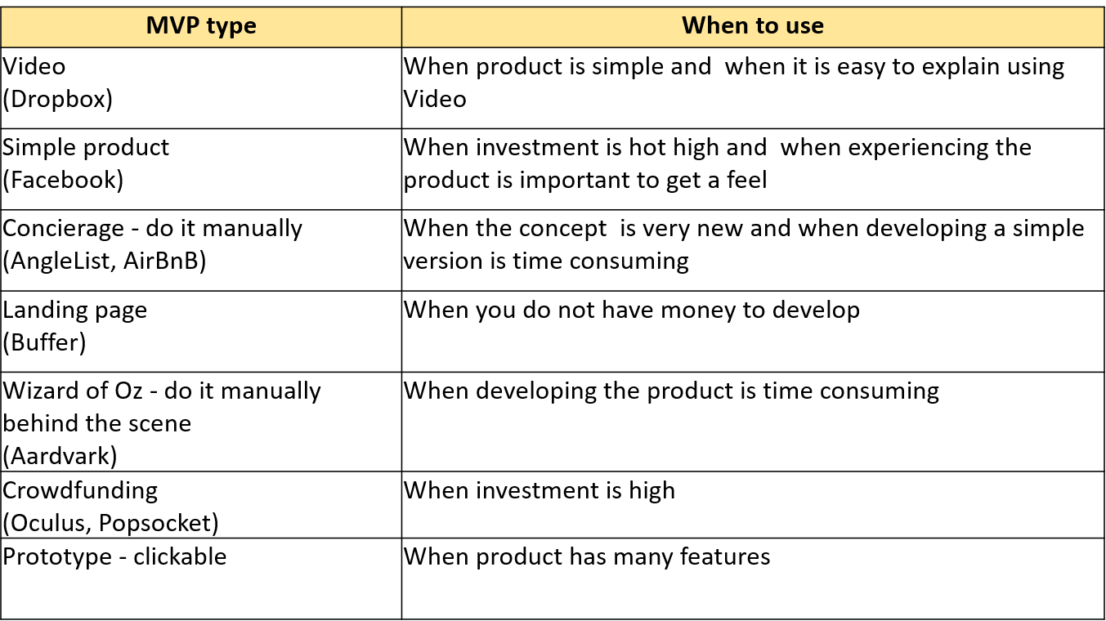

The choice of MVP type to use depends on the product, its stage in the development process, and the needs of the users. Here are some scenarios when each MVP type can be used:

1. Exploratory MVP: When the product concept is new and the team needs to explore the user needs, the exploratory MVP can be used to get feedback from early adopters.
2. Concierge MVP: When the team has a hypothesis about a problem and the solution but is not sure about the features, the concierge MVP can be used to provide a personalized experience to a small group of users.
3. Wizard of Oz MVP: When the team wants to test the user experience of a feature before building it, the Wizard of Oz MVP can be used to simulate the feature with manual work.
4. Piecemeal MVP: When the team wants to test the functionality of different features, the piecemeal MVP can be used to test each feature separately.
5. Landing Page MVP: When the team wants to test the demand for the product, the landing page MVP can be used to collect email addresses of interested users and get feedback on the product.
6. Prototype MVP: When the team wants to test the usability of the product, the prototype MVP can be used to provide a realistic simulation of the product's functionality.

Overall, the choice of MVP type should be made based on the product goals, user needs, and the stage of product development

## Build-Measure-Learn (Lean Start-up)

Build-Measure-Learn is a fundamental principle of the Lean Start-up methodology that focuses on creating a product or service that meets the needs of customers by continuously testing and iterating the product. The Build-Measure-Learn cycle is a feedback loop that consists of three stages:

1. Build: In this stage, the start-up creates a Minimum Viable Product (MVP) that contains only the essential features that solve the core problem of the customers.
2. Measure: In this stage, the start-up collects data from customers to evaluate how they are using the product, what features they like, and what areas need improvement. This data can be collected through surveys, customer feedback, or analytics tools.
3. Learn: In this stage, the start-up uses the feedback obtained from customers to improve the product or service. The goal is to identify what features are valuable to customers and what features should be removed or modified to enhance the user experience.

The Build-Measure-Learn cycle is repeated continuously, allowing the start-up to iterate and refine the product until it meets the needs of the customers. The Lean Start-up methodology emphasizes the importance of validating assumptions about the product or service early on, reducing the risk of investing resources in a product that may not be successful

### Build – Turn ideas into product

Building a product involves turning ideas into a tangible product that solves a problem or meets a need for a target market. This phase of product development is focused on creating a prototype or minimum viable product (MVP) that can be tested and refined based on user feedback.

The process of building a product can be broken down into several key steps:

1. Design: This involves creating a plan or blueprint for the product that includes the features, functionality, and user interface.
2. Development: Once the design is complete, the product can be developed using a range of programming languages and software tools. This involves coding, testing, and debugging the product to ensure it functions correctly.
3. Testing: The product should be rigorously tested to ensure it meets the required standards and functionality. This may involve testing for usability, performance, security, and compatibility.
4. Launch: Once the product has been developed and tested, it can be launched to the market. This may involve creating marketing campaigns, pricing strategies, and sales plans to promote the product and drive adoption.
5. Iteration: After the product has been launched, it is important to continue to gather feedback and make improvements to the product based on user needs and preferences. This process of continuous improvement can help to ensure the product remains relevant and competitive over time

### Measure – See how customers respond

The "Measure" step in the Build-Measure-Learn cycle involves measuring how customers respond to the product. This includes gathering data on customer usage and behavior, as well as collecting feedback through surveys, user testing, and other methods.

The goal of measurement is to gain insight into how the product is being used, how customers are responding to it, and how it can be improved. This information can then be used to make data-driven decisions about future development and to guide the next iteration of the product.

Metrics are a key component of the measurement process. Product managers need to identify the most relevant metrics to measure, such as user engagement, retention, and conversion rates. These metrics should be aligned with the product goals and help to measure progress towards those goals.

Overall, the measure step is about gathering data and insights to inform the next phase of the Build-Measure-Learn cycle. It's important to approach measurement with an open mind and a willingness to learn from customer feedback, even if it challenges initial assumptions or hypotheses

### Learn – Pivot or persevere

After measuring the customers' response to the product, the next step in the Build-Measure-Learn cycle is to learn from the feedback received and make necessary changes to the product. The main objective of the learning phase is to decide whether to pivot or persevere with the product.

If the feedback received indicates that the product is not meeting the customers' needs or is not creating sufficient demand, it may be necessary to pivot the product by changing the direction, focus, or approach of the product. Pivoting involves making significant changes to the product to improve its chances of success.

If the feedback received indicates that the product is meeting customers' needs and creating sufficient demand, it may be necessary to persevere with the product and continue to improve it based on the feedback received. In this case, the focus would be on optimizing the product for the target market and maximizing its potential.

The key to successful learning is to gather relevant data and feedback, analyze it objectively, and use it to make informed decisions about the product's direction and future

### Profile: Kate Arnold of Netflix (Inspired)

Kate Arnold is a product manager at Netflix, a leading streaming service. She has been with the company for over seven years and has worked on a variety of projects, including the development of original content and the integration of new technologies into the platform.

Arnold's role at Netflix is to oversee the product development process from ideation to launch. She works closely with cross-functional teams, including engineers, designers, and content creators, to ensure that the products meet the needs of Netflix's subscribers.

One of Arnold's major contributions to Netflix has been her work on the company's original content strategy. She played a key role in the development of hit shows like Stranger Things, The Crown, and Orange is the New Black. Arnold's ability to identify promising new ideas and work with creative talent to bring them to fruition has been essential to Netflix's success in the highly competitive streaming market.

Arnold is also known for her strong customer-centric approach to product management. She regularly engages with Netflix subscribers to gain insights into their needs and preferences. This feedback is then incorporated into the product development process to ensure that Netflix continues to deliver a best-in-class user experience.

Overall, Kate Arnold's work at Netflix exemplifies the key principles of product management, including a deep understanding of customer needs, strong collaboration skills, and a focus on delivering high-quality products that meet the needs of the market

# Question paper Mid term solution

1. LOANS is a micro-finance institution helps marginal business owners by providing loans – and hope – to the poorest. Being product manager/owner,
   1. Identify software product opportunities [3]
   2. Identify risks in assessment [3]
   3. How to Build-Measure-Learn and Pivot for the opportunities and risks identified above? [3]

### 1 Ans:

(a) Identify software product opportunities:

1. Loan application and approval software that streamlines the loan application and approval process.
2. Customer relationship management software that helps manage customer data, track customer interactions, and provide personalized service.
3. Financial management software that helps business owners manage their finances, track expenses, and generate financial reports.
4. Mobile apps that allow customers to access their loan information, make payments, and communicate with loan officers.
5. Analytics software that helps identify trends and patterns in loan applications and customer behavior.

(b) Identify risks in assessment:

1. Credit risk: There is a risk that borrowers will default on their loans, which could lead to financial losses for the institution.
2. Operational risk: There is a risk that loan processing and administration may not be efficient or effective, which could lead to delays or errors in loan processing.
3. Compliance risk: There is a risk that the institution may not comply with regulatory requirements, which could lead to fines or other penalties.
4. Reputational risk: There is a risk that negative publicity or customer dissatisfaction could harm the institution's reputation and reduce future loan applications.

(c) How to Build-Measure-Learn and Pivot for the opportunities and risks identified above?

1. Build: Develop the software products identified above using agile development methodologies to quickly build and test prototypes and iterate based on customer feedback.
2. Measure: Use data analytics to measure the effectiveness of the software products in improving loan application and approval processes, customer satisfaction, and loan performance.
3. Learn: Gather feedback from customers and stakeholders, analyze data, and use insights to identify opportunities for improvement and further development.
4. Pivot: Based on the feedback and data gathered, make strategic decisions to pivot or adjust the software products to better meet the needs of customers and address any risks identified. For example, if the credit risk is too high, consider adjusting the loan approval process or criteria to reduce the risk of defaults. If the compliance risk is too high, consider implementing additional regulatory controls or processes
5. XYZ 24|7 is an online platform where you have access to a wide range of services such as online pharmacy, [online doctor consultations](https://www.apollo247.com/specialties), and diagnostic [lab tests at home](https://www.apollo247.com/lab-tests). We also provide expert solutions for chronic conditions and COVID-care with a secured digital vault, where you can safely upload all your medical reports.
   1. Identify software product opportunities [3]
   2. Identify risks in assessment [3]

How to Build-Measure-Learn and Pivot for the opportunities and risks identified above?

### 2 Ans:

(a) Software product opportunities for XYZ 24|7 could include:

* Developing a mobile application to enhance accessibility and convenience for users.
* Implementing machine learning algorithms to personalize medical solutions for chronic conditions.
* Developing a dashboard for doctors to monitor patient's health status and provide personalized care.

(b) Risks in assessment for XYZ 24|7 could include:

* Data security and privacy risks for users' medical information.
* Regulatory compliance risks related to online pharmacy and telemedicine services.
* User adoption and retention risks due to competition from established players in the healthcare industry.

(c) To Build-Measure-Learn and Pivot for the opportunities and risks identified above, XYZ 24|7 could follow these steps:

* Build: Develop a minimum viable product (MVP) for each identified opportunity to test the concept and validate user demand.
* Measure: Analyze user feedback, engagement metrics, and financial performance to evaluate the success of the MVP.
* Learn: Use the insights gained from measuring to refine the MVP and iterate on the product.
* Pivot: If the MVP fails to gain traction or the risks outweigh the benefits, pivot the product strategy to address the identified risks or shift focus to a different opportunity.

1. An over-the-top (OTT) media service is a [media](https://en.wikipedia.org/wiki/Media_(communications)) service offered [directly to viewers](https://en.wikipedia.org/wiki/Direct-to-consumer) via the [Internet](https://en.wikipedia.org/wiki/Internet). OTT bypasses [cable](https://en.wikipedia.org/wiki/Cable_television), [broadcast](https://en.wikipedia.org/wiki/Broadcast_television), and [satellite television](https://en.wikipedia.org/wiki/Satellite_television) platforms, the types of companies that traditionally act as controllers or distributors of such content. Being product manager/owner,
   1. Identify software product opportunities [3]
   2. Identify risks in assessment [3]

How to Build-Measure-Learn and Pivot for the opportunities and risks identified above?

### 3 Ans:

(a) Opportunities for software products in the OTT media service industry could include:

* Developing a user-friendly OTT platform that offers a wide range of content, including both original and licensed content.
* Offering customized recommendations and personalized content suggestions based on user viewing history and preferences.
* Developing an OTT platform that supports multiple devices, including smartphones, tablets, smart TVs, and gaming consoles.
* Integrating social media features into the OTT platform, such as the ability to share content with friends and family, post reviews, and engage in discussions with other viewers.

(b) Risks in assessment for an OTT media service could include:

* Competition from established OTT platforms, such as Netflix, Amazon Prime Video, and Hulu, which have a large user base and significant brand recognition.
* Technical challenges, such as ensuring that the OTT platform is reliable, secure, and able to handle high traffic volumes.
* Legal and regulatory risks, such as compliance with copyright laws and data privacy regulations.
* Financial risks, such as the high cost of acquiring content rights and the need to invest in marketing and advertising to attract and retain users.

(c) To Build-Measure-Learn and Pivot for the opportunities and risks identified above, the product manager/owner could:

* Build a Minimum Viable Product (MVP) that includes the core features and functionality of the OTT platform and test it with a small group of users.
* Measure user engagement and satisfaction with the MVP through user feedback, user behavior analytics, and other metrics.
* Learn from user feedback and data to refine the OTT platform and add new features and functionality based on user needs and preferences.
* Pivot the product strategy if necessary based on market feedback and changing user needs, such as expanding the content offerings, targeting specific niche audiences, or focusing on a particular device or platform.

1. ABC is a General Insurance company, which offer Car, Two-Wheeler, Taxi and Health Insurance plans. Being product manager/owner,
   1. Describe Product-Market fit analysis [3]
   2. Provide the Story Map using Kano Model [3]
   3. Explain the Rapid Prototyping process to reach MVP [3]

### 2A Ans:

(a) Product-Market fit analysis is a process of determining whether a product is meeting the needs of its target market. It involves evaluating how well the product is solving the problems and addressing the needs of the customers. To perform a Product-Market fit analysis, the following steps can be taken:

1. Define the target market and the customers' needs and pain points
2. Evaluate how well the product addresses these needs
3. Determine if there is a demand for the product
4. Analyze the competition and identify the unique selling proposition of the product
5. Identify the key metrics to measure the success of the product in the market

(b) A Story Map using Kano Model for ABC Insurance can be created as follows:

High satisfaction:

* Car insurance policy with zero depreciation
* Two-wheeler insurance policy with accident coverage
* Health insurance plan with cashless hospitalization

Medium satisfaction:

* Car insurance policy with roadside assistance
* Two-wheeler insurance policy with theft protection
* Health insurance plan with critical illness coverage

Low satisfaction:

* Car insurance policy with no-claim bonus
* Two-wheeler insurance policy with third-party liability coverage
* Health insurance plan with pre-existing disease coverage

(c) The Rapid Prototyping process for ABC Insurance to reach MVP can be explained as follows:

1. Define the MVP requirements based on the product-market fit analysis and the Story Map using Kano Model.
2. Create a simple mockup or a wireframe of the MVP.
3. Test the MVP with a small group of users to get feedback and identify any issues or areas for improvement.
4. Iterate and refine the MVP based on the feedback and testing results.
5. Test the refined MVP with a larger group of users to validate the assumptions and measure the key metrics identified in the Product-Market fit analysis.
6. Continue iterating and refining the MVP until it meets the needs of the target market and achieves the desired results.
7. ABC is a General Insurance company, which offer Car, Two-Wheeler, Taxi and Health Insurance plans. Being product manager/owner,
   1. Describe Product-Market fit analysis [3]
   2. Provide the Story Map using Kano Model [3]
   3. Explain the Rapid Prototyping process to reach MVP [3]

### 2B Ans:

(a) Product-Market fit analysis involves identifying the target market for the product, analyzing the needs and preferences of the customers, and evaluating how well the product satisfies those needs. The analysis can be done by collecting customer feedback, conducting surveys, analyzing user data, and assessing market trends. The goal of the analysis is to ensure that the product aligns with the needs of the target market, and there is a demand for the product in the market.

(b) Story Map using Kano Model:

* Must-Have Features: Basic coverage for Car, Two-wheeler, Taxi, and Health Insurance plans
* Performance Features: Fast and easy claim settlement process, 24/7 customer support, Online policy renewal, and access to policy documents
* Delightful Features: Personalized recommendations based on customer needs, Discounts on policy renewals, and Wellness programs for Health Insurance customers

(c) Rapid Prototyping process involves developing a quick and rough version of the product to test and validate the product concept with potential customers. The process includes the following steps:

1. Ideation and Conceptualization: Brainstorming ideas and developing a concept for the product.
2. Sketching and Wireframing: Creating rough sketches and wireframes of the product to visualize the product's layout and features.
3. Building a Prototype: Developing a basic and functional version of the product with minimum features and functionalities.
4. Testing and Validation: Conducting user testing and collecting feedback from potential customers to validate the product concept and identify areas of improvement.
5. Iteration: Refining the product based on customer feedback and iterating the development process until the product meets the customer's needs and expectations.

By following the rapid prototyping process, the product team can develop an MVP that meets the customer's needs, is easy to use, and provides a seamless user experience.

1. ABC is a General Insurance company, which offer Car, Two-Wheeler, Taxi and Health Insurance plans. Being product manager/owner,
   1. Describe Product-Market fit analysis [3]
   2. Provide the Story Map using Kano Model [3]
   3. Explain the Rapid Prototyping process to reach MVP [3]

### 2C Ans:

(a) Product-Market fit analysis is the process of determining whether a product meets the needs of its target market. It involves gathering feedback from customers and analyzing data to determine whether the product is delivering value to the market. The goal is to ensure that there is a match between the product and the target market to achieve success.

(b) Story Map using Kano Model:

1. Must-Have Features:

* Comprehensive coverage for all types of vehicles and health insurance plans
* Easy and hassle-free claim process
* Affordable premiums

1. Performance Features:

* Quick claim settlement process
* Customizable policies
* 24/7 customer support

1. Delight Features:

* Personalized policy recommendations based on individual needs
* Value-added services such as roadside assistance, health checkups, and wellness programs
* Mobile app for easy access to policy information and claim processing

(c) The Rapid Prototyping process is an iterative approach to product development that involves quickly building and testing product prototypes to gather feedback and improve the product. The process involves the following steps:

1. Identify the problem or opportunity: Determine the customer pain points and identify areas for improvement in the existing product.
2. Ideate and conceptualize: Brainstorm potential solutions and create rough sketches or wireframes to visualize the product.
3. Build a prototype: Develop a basic version of the product that can be tested with a small group of users.
4. Test and gather feedback: Test the prototype with users and gather feedback on the product's features, usability, and overall experience.
5. Iterate and improve: Use the feedback to refine the product, make necessary changes, and build an improved version.
6. Repeat the process: Continue the process of building and testing prototypes until the product meets the needs of the target market and achieves Product-Market fit.